Allied Security Operations Group
Antrim Michigan Forensics Report REVISED PRELIMINARY SUMMARY, v2
Report Date 12/13/2020

Client: Bill Bailey Attorney: Matthew DePerno
- WHO WE ARE

  - My name is Russell James Ramsland, Jr., and I am a resident of Dallas County, Texas. I hold an MBA from Harvard University, and a political science degree from Duke University. I have worked with the National Aeronautics and Space Administration (NASA) and the Massachusetts Institute of Technology (MIT), among other organizations, and have run businesses all over the world, many of which are highly technical in nature. I have served on technical government panels.

  - I am part of the management team of Allied Security Operations Group, LLC, (ASOG). ASOG is a group of globally engaged professionals who come from various disciplines to include Department of Defense, Secret Service, Department of Homeland Security, and the Central Intelligence Agency. It provides a range of security services, but has a particular emphasis on cybersecurity, open source investigation and penetration testing of networks. We employ a wide variety of cyber and cyber forensic analysts. We have patents pending in a variety of applications from novel network security applications to SCADA (Supervisory Control and Data Acquisition) protection and safe browsing solutions for the dark and deep web. For this report, I have relied on these experts and resources.

PURPOSE AND PRELIMINARY CONCLUSIONS

  - The purpose of this forensic audit is to test the integrity of Dominion Voting System in how it performed in Antrim County, Michigan for the 2020 election.

  - We conclude that the Dominion Voting System is intentionally and purposefully designed with inherent errors to create systemic fraud and influence election results. The system intentionally generates an enormously high number of ballot errors. The electronic ballots are then transferred for adjudication. The intentional errors lead to bulk adjudication of ballots with no oversight, no transparency, and no audit trail. This leads to voter or election fraud. Based on our study, we conclude that The Dominion Voting System should not be used in Michigan. We further conclude that the results of Antrim County should not have been certified.

  - The following is a breakdown of the votes tabulated for the 2020 election in Antrim County, showing different dates for the tabulation of the same votes.

Date | Registered Voters | Total Votes Cast | Biden | Trump | Third Party | Write-In | TOTAL VOTES  for President
Nov 3 | 22,082 | 16,047 | 7,769 | 4,509 | 145 | 14 | 12,423
Nov 5 | 22,082 | 18,059 | 7,289 | 9,783 | 255 | 20 | 17,327
Nov 21 | 22,082 | 16,044 | 5,960 | 9,748 | 241 | 23 | 15,949

  - The Antrim County Clerk and Secretary of State Jocelyn Benson have stated that the election night error (detailed above by the vote "flip" from Trump to Biden, was the result of human error caused by the failure to update the Mancelona Township tabulator prior to election night for a down ballot race. We disagree and conclude that the vote flip occurred because of machine error built into the voting software designed to create error.

  - Secretary of State Jocelyn Benson's statement on November 6, 2020 that "[t]the correct results always were and continue to be reflected on the tabulator totals tape " was false.

  - The allowable election error rate established by the Federal Election Commission guidelines is of 1 in 250,000 ballots (.0008%). We observed an error rate of 68.05%. This demonstrated a significant and fatal error in security and election integrity.

  - The results of the Antrim County 2020 election are not certifiable. This is a result of machine and/or software error, not human error.

  - The tabulation log for the forensic examination of the server for Antrim County from December 6, 2020consists of 15,676 individual events, of which 10,667 or 68.05% of the events were recorded errors. These errors resulted in overall tabulation errors or ballots being sent to adjudication. This high error rates proves the Dominion Voting System is flawed and does not meet state or federal election laws.

  - These errors occurred after The Antrim County Clerk provided a re-provisioned CF card with uploaded software for the Central Lake Precinct on November 6, 2020. This means the statement by Secretary Benson was false. The Dominion Voting System produced systemic errors and high error rates both prior to the update and after the update; meaning the update (or lack of update) is not the cause of errors.

  - In Central Lake Township there were 1,222 ballots reversed out of 1,491 total ballots cast, resulting in an 81.96% rejection rate. All reversed ballots are sent to adjudication for a decision by election personnel.

  - It is critical to understand that the Dominion system classifies ballots into two categories, 1) normal ballots and 2) adjudicated ballots. Ballots sent to adjudication can be altered by administrators, and adjudication files can be moved between different Results Tally and Reporting (RTR) terminals with no audit trail of which administrator actually adjudicates (i.e. votes) the ballot batch. This demonstrated a significant and fatal error in security and election integrity because it provides no meaningful observation of the adjudication process or audit trail of which administrator actually adjudicated the ballots.

  - A staggering number of votes required adjudication. This was a 2020 issue not seen in previous election cycles still stored on the server. This is caused by intentional errors in the system. The intentional errors lead to bulk adjudication of ballots with no oversight, no transparency or audit trail. Our examination of the server logs indicates that this high error rate was incongruent with patterns from previous years. The statement attributing these issues to human error is not consistent with the forensic evaluation, which points more correctly to systemic machine and/or software errors. The systemic errors are intentionally designed to create errors in order to push a high volume of ballots to bulk adjudication.

  - The linked video demonstrates how to cheat at adjudication: https://mobile.twitter.com/KanekoaTheGreat/status/1336888454538428418
  - Antrim County failed to properly update its system. A purposeful lack of providing basic computer security updates in the system software and hardware demonstrates incompetence, gross negligence, bad faith, and/or willful non- compliance in providing the fundamental system security required by federal and state law. There is no way this election management system could have passed tests or have been legally certified to conduct the 2020 elections in Michigan under the current laws. According to the National Conference of State Legislatures – Michigan requires full compliance with federal standards as determined by a federally accredited voting system laboratory.

  - Significantly, the computer system shows vote adjudication logs for prior years; but all adjudication log entries for the 2020 election cycle are missing. The adjudication process is the simplest way to manually manipulate votes. The lack of records prevents any form of audit accountability, and their conspicuous absence is extremely suspicious since the files exist for previous years using the same software. Removal of these files violates state law and prevents a meaningful audit, even if the Secretary wanted to conduct an audit. We must conclude that the 2020 election cycle records have been manually removed.

  - Likewise, all server security logs prior to 11:03 pm on November 4, 2020 are missing. This means that all security logs for the day after the election, on election day, and prior to election day are gone. Security logs are very important to an audit trail, forensics, and for detecting advanced persistent threats and outside attacks, especially on systems with outdated system files. These logs would contain domain controls, authentication failures, error codes, times users logged on and off, network connections to file servers between file accesses, internet connections, times, and data transfers. Other server logs before November 4, 2020 are present; therefore, there is no reasonable explanation for the security logs to be missing.

  - On November 21, 2020, an unauthorized user unsuccessfully attempted to zero out election results. This demonstrates additional tampering with data.

  - The Election Event Designer Log shows that Dominion ImageCast Precinct Cards were programmed with new ballot programming on 10/23/2020 and then again after the election on 11/05/2020. These system changes affect how ballots are read and tabulated, and our examination demonstrated a significant change in voter results using the two different programs. In accordance with the Help America Vote Act, this violates the 90-day Safe Harbor Period which prohibits changes to election systems, registries, hardware/software updates without undergoing re-certification. According to the National Conference of State Legislatures – Michigan requires full compliance with federal standards as determined by a federally accredited voting system laboratory.

  - The only reason to change software after the election would be to obfuscate evidence of fraud and/or to correct program errors that would de-certify the election. Our findings show that the Central Lake Township tabulator tape totals were significantly altered by utilizing two different program versions (10/23/2020 and 11/05/2020), both of which were software changes during an election which violates election law, and not just human error associated with the Dominion Election Management System. This is clear evidence of software generated movement of votes. The claims made on the Office of the Secretary of State website are false.

  - The Dominion ImageCast Precinct (ICP) machines have the ability to be connected to the internet (see Image 11). By connecting a network scanner to the ethernet port on the ICP machine and creating Packet Capture logs from the machines we examined show the ability to connect to the network, Application Programming Interface (API) (a data exchange between two different systems) calls and web (http) connections to the Election Management System server. Best practice is to disable the network interface card to avoid connection to the internet. This demonstrated a significant and fatal error in security and election integrity. Because certain files have been deleted, we have not yet found origin or destination; but our research continues.

  - Because the intentional high error rate generates large numbers of ballots to be adjudicated by election personnel, we must deduce that bulk adjudication occurred. However, because files and adjudication logs are missing, we have not yet determined where the bulk adjudication occurred or who was responsible for it. Our research continues.

  - Research is ongoing. However, based on the preliminary results, we conclude that the errors are so significant that they call into question the integrity and legitimacy of the results in the Antrim County 2020 election to the point that the results are not certifiable. Because the same machines and software are used in
48 other counties in Michigan, this casts doubt on the integrity of the entire election in the state of Michigan.

  - DNI Responsibilities: President Obama signed Executive Order on National Critical Infrastructure on 6 January 2017, stating in Section 1. Cybersecurity of Federal Networks, "The Executive Branch operates its information technology (IT) on behalf of the American people. The President will hold heads of executive departments and agencies (agency heads) accountable for managing cybersecurity risk to their enterprises. In addition, because risk management decisions made by agency heads can affect the risk to the executive branch as a whole, and to national security, it is also the policy of the United States to manage cybersecurity risk as an executive branch enterprise." President Obama's EO further stated, effective immediately, each agency head shall use The Framework for Improving Critical Infrastructure Cybersecurity (the Framework) developed by the National Institute of Standards and Technology." Support to Critical Infrastructure at Greatest Risk. The Secretary of Homeland Security, in coordination with the Secretary of Defense, the Attorney General, the Director of National Intelligence, the Director of the Federal Bureau of Investigation, the heads of appropriate sector-specific agencies, as defined in Presidential Policy Directive 21 of February 12, 2013 (Critical Infrastructure Security and Resilience) (sector-specific agencies), and all other appropriate agency heads, as identified by the Secretary of Homeland Security, shall: (i) identify authorities and capabilities that agencies could employ to support the cybersecurity efforts of critical infrastructure entities identified pursuant to section
9 of Executive Order 13636 of February 12, 2013 (Improving Critical Infrastructure Cybersecurity), to be at greatest risk of attacks that could reasonably result in catastrophic regional or national effects on public health or safety, economic security, or national security (section 9 entities);

This is a national security imperative. In July 2018, President Trump strengthened President Obama’s Executive Order to include requirements to ensure US election systems, processes, and its people were not manipulated by foreign meddling, either through electronic or systemic manipulation, social media, or physical changes made in hardware, software, or supporting systems. The 2018 Executive Order. Accordingly, I hereby order:

Section 1. (a) Not later than 45 days after the conclusion of a United States election, the Director of National Intelligence, in consultation with the heads of any other appropriate executive departments and agencies (agencies), shall conduct an assessment of any information indicating that a foreign government, or any person acting as an agent of or on behalf of a foreign government, has acted with the intent or purpose of interfering in that election. The assessment shall identify, to the maximum extent ascertainable, the nature of any foreign interference and any methods employed to execute it, the persons involved, and the foreign government or governments that authorized, directed, sponsored, or supported it. The Director of National Intelligence shall deliver this assessment and appropriate supporting information to the President, the Secretary of State, the Secretary of the Treasury, the Secretary of Defense, the Attorney General, and the Secretary of Homeland Security.

We recommend that an independent group should be empaneled to determine the extent of the adjudication errors throughout the State of Michigan. This is a national security issue.

  - Michigan resident Gustavo Delfino, a former professor of mathematics in Venezuela and alumni of University of Michigan, offered a compelling affidavit [Exhibit 2] recognizing the inherent vulnerabilities in the SmartMatic electronic voting machines (software which was since incorporated into Dominion Voting Systems) during the 2004 national referendum in Venezuela (see attached declaration). After 4 years of research and 3 years of undergoing intensive peer review, Professor Delfino’s paper was published in the highly respected "Statistical Science" journal, November 2011 issue (Volume 26, Number 4) with title "Analysis of the 2004 Venezuela Referendum: The Official Results Versus the Petition Signatures." The intensive study used multiple mathematical approaches to ascertain the voting results found in the 2004 Venezuelan referendum. Delfino and his research partners discovered not only the algorithm used to manipulate the results, but also the precise location in the election processing sequence where vulnerability in machine processing would provide such an opportunity. According to Prof Delfino, the magnitude of the difference between the official and the true result in Venezuela estimated at 1,370,000 votes. Our investigation into the error rates and results of the Antrim County voting tally reflect the same tactics, which have also been reported in other Michigan counties as well. This demonstrates a national security issue.

PROCESS

We visited Antrim County twice: November 27, 2020 and December 6, 2020.

On November 27, 2020, we visited Central Lake Township, Star Township, and Mancelona Township. We examined the Dominion Voting Systems tabulators and tabulator roles.

On December 6, 2020, we visited the Antrim County Clerk's office. We inspected and performed forensic duplication of the following:

  - Antrim County Election Management Server running Dominion Democracy Suite 5.5.3-002;

  - Compact Flash cards used by the local precincts in their Dominion ImageCast Precinct;

  - USB memory sticks used by the Dominion VAT (Voter Assist Terminals); and

  - USB memory sticks used for the Poll Book.

Dominion voting system is a Canadian owned company with global subsidiaries. It is owned by Staple Street Capital which is in turn owned by UBS Securities LLC, of which 3 out of their 7 board members are Chinese nationals. The Dominion software is licensed from Smartmatic which is a Venezuelan owned and controlled company. Dominion Server locations have been determined to be in Serbia, Canada, the US, Spain and Germany.

CENTRAL LAKE TOWNSHIP

  - On November 27, 2020, part of our forensics team visited the Central Lake Township in Michigan to inspect the Dominion ImageCast Precint for possible hardware issues on behalf of a local lawsuit filed by Michigan attorney Matthew DePerno on behalf of William Bailey. In our conversations with the clerk of Central Lake Township Ms. Judith L. Kosloski, she presented to us "two separate paper totals tape" from Tabulator ID 2.

    - One dated "Poll Opened Nov. 03/2020 06:38:48" (Roll 1);
    - Another dated "Poll Opened Nov. 06/2020 09:21:58" (Roll 2).
  - We were then told by Ms. Kosloski that on November 5, 2020, Ms. Kosloski was notified by Connie Wing of the County Clerk's Office and asked to bring the tabulator and ballots to the County Clerk's office for re-tabulation. They ran the ballots and printed "Roll 2". She noticed a difference in the votes and brought it up to the clerk, but canvasing still occurred, and her objections were not addressed.

  - Our team analyzed both rolls and compared the results. Roll 1 had 1,494 total votes and Roll 2 had 1,491 votes (Roll 2 had 3 less ballots because 3 ballots were damaged in the process.)

  - "Statement of Votes Cast from Antrim" shows that only 1,491 votes were counted, and the 3 ballots that were damaged were not entered into final results.

  - Ms. Kosloski stated that she and her assistant manually refilled out the three ballots, curing them, and ran them through the ballot counting system - but the final numbers do not reflect the inclusion of those 3 damaged ballots.

  - This is the most preliminary report of serious election fraud indicators. In comparing the numbers on both rolls, we estimate 1,474 votes changed across the two rolls, between the first and the second time the exact same ballots were run through the County Clerk’s vote counting machine - which is almost the same number of voters that voted in total.

    - 742 votes were added to School Board Member for Central Lake Schools (3)

    - 657 votes were removed from School Board Member for Ellsworth Schools (2)

    - 7 votes were added to the total for State Proposal 20-1 (1) and out of those there were 611 votes moved between the Yes and No Categories.

  - There were incremental changes throughout the rolls with some significant adjustments between the 2 rolls that were reviewed. This demonstrates conclusively that votes can be and were changed during the second machine count after the software update. That should be impossible especially at such a high percentage to total votes cast.

  - For the School Board Member for Central Lake Schools (3) [Image 1] there were 742 votes added to this vote total. Since multiple people were elected, this did not change the result of both candidates being elected, but one does see a change in who had most votes. If it were a single-person election this would have changed the outcome and demonstrates conclusively that votes can be and were changed during the second machine counting. That should be impossible.

[Image 1]:
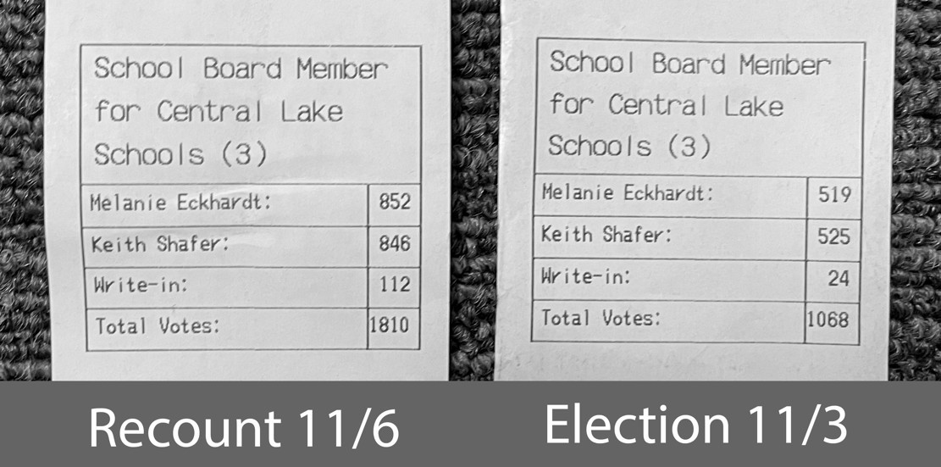

  - For the School Board Member for Ellsworth Schools (2) [Image 2]
    - Shows 657 votes being removed from this election.
    - In this case, only 3 people who were eligible to vote actually voted. Since there were 2 votes allowed for each voter to cast.

    - The recount correctly shows 6 votes.
But on election night, there was a major calculation issue: [Image 2]:
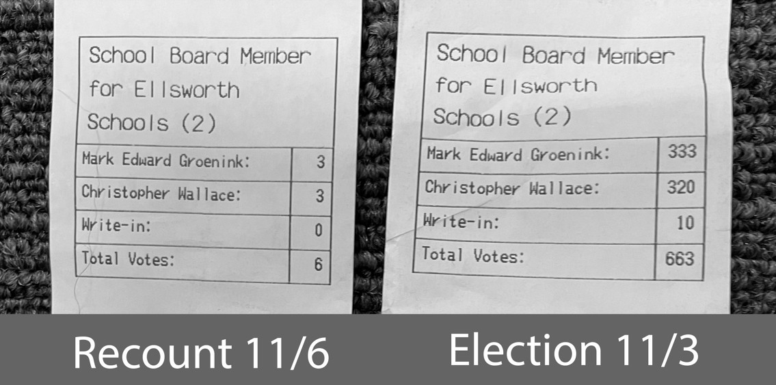
  - In State Proposal 20-1 (1), [Image 3] there is a major change in votes in this category.
    - There were 774 votes for YES during the election, to 1,083 votes for YES on the recount a change of 309 votes.

    - 7 votes were added to the total for State Proposal 20-1 (1) out of those there were 611 votes moved between the Yes and No Categories.

[Image 3]:

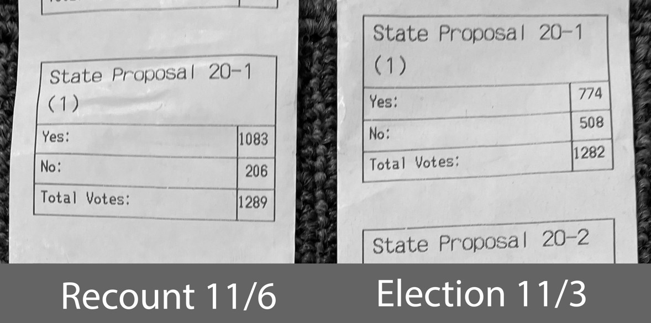

  - State Proposal 20-1 (1) is a fairly technical and complicated proposed amendment to the Michigan Constitution to change the disposition and allowable uses of future revenue generated from oil and gas bonuses, rentals and royalties from state-owned land. Information about the proposal: https://crcmich.org/publications/statewide-ballot- proposal-20-1-michigan-natural- resources-trust-fund

  - A Proposed Initiated Ordinance to Authorize One (1) Marihuana (sic) Retailer Establishment Within the Village of Central Lake (1). [Image 4]

    - On election night, it was a tie vote.
    - Then, on the rerun of ballots 3 ballots were destroyed, but only one vote changed on the totals to allow the proposal to pass.

When 3 ballots were not counted and programming change on the tabulator was installed the proposal passed with 1 vote being removed from the No vote.

[Image 4]:

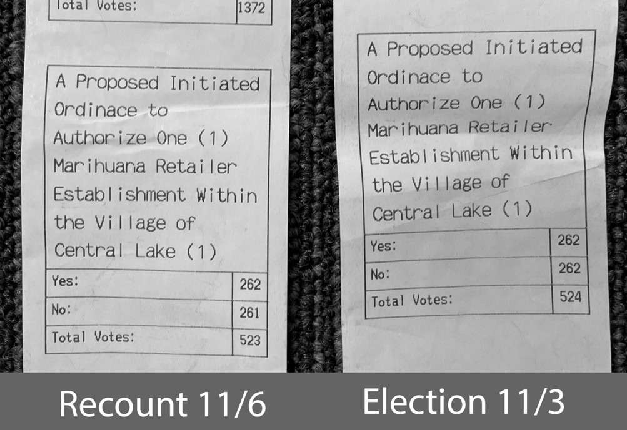

  - On Sunday December 6, 2020, our forensics team visited the Antrim County Clerk. There were two USB memory sticks used, one contained the software package used to tabulate election results on November 3, 2020, and the other was programmed on November 6, 2020 with a different software package which yielded significantly different voting outcomes. The election data package is used by the Dominion Democracy Suite software & election management system software to upload programming information onto the Compact Flash Cards for the Dominion ImageCast Precinct to enable it to calculate ballot totals.

  - This software programming should be standard across all voting machines systems for the duration of the entire election if accurate tabulation is the expected outcome as required by US Election Law. This intentional difference in software programming is a design feature to alter election outcomes.

  - The election day outcomes were calculated using the original software programming on November 3, 2020. On November 5, 2020 the township clerk was asked to re-run the Central Lake Township ballots and was given no explanation for this unusual request. On November 6, 2020 the Antrim County Clerk, Sheryl Guy issued the second version of software to re-run the same Central Lake Township ballots and oversaw the process. This resulted in greater than a 60% change in voting results, inexplicably impacting every single election contest in a township with less than 1500 voters. These errors far exceed the ballot error rate standard of 1 in 250,000 ballots (.0008%) as required by federal election law.

    - The original election programming files are last dated 09/25/2020 1:24pm
    - The updated election data package files are last dated 10/22/2020 10:27 am.

  - As the tabulator tape totals prove, there were large numbers of votes switched from the November 3, 2020 tape to the November 6, 2020 tape. This was solely based on using different software versions of the operating program to calculate votes, not tabulate votes. This is evidenced by using same the Dominion System with two different software program versions contained on the two different USB Memory Devices.

  - The Help America Vote Act, Safe Harbor provides a 90-day period prior to elections where no changes can be made to election systems. To make changes would require recertification of the entire system for use in the election. The Dominion User Guide prescribes the proper procedure to test machines with test ballots to compare the results to validate machine functionality to determine if the Dominion ImageCast Precinct was programmed correctly. If this occurred a ballot misconfiguration would have been identified. Once the software was updated to the 10/22/2020 software the test ballots should have been re-run to validate the vote totals to confirm the machine was configured correctly.

  - The November 6, 2020 note from The Office of the Secretary of State Jocelyn Benson states: "The correct results always were and continue to be reflected on the tabulator totals tape and on the ballots themselves. Even if the error in the reported unofficial results had not been quickly noticed, it would have been identified during the county canvass. Boards of County Canvassers, which are composed of 2 Democrats and 2 Republicans, review the printed totals tape from each tabulator during the canvass to verify the reported vote totals are correct."

    - Source: https://www.michigan.gov/sos/0,4670,7-127-1640_9150-544676--
,00.html

  - The Secretary of State Jocelyn Benson's statement is false. Our findings show that the tabulator tape totals were significantly altered by utilization of two different program versions, and not just the Dominion Election Management System. This is the opposite of the claim that the Office of the Secretary of State made on its website. The fact that these significant errors were not caught in ballot testing and not caught by the local county clerk shows that there are major inherent built-in vulnerabilities and process flaws in the Dominion Election Management System, and that other townships/precincts and the entire election have been affected.

  - On Sunday December 6, 2020, our forensics team visited the Antrim County Clerk office to perform forensic duplication of the Antrim County Election Management Server running Dominion Democracy Suite 5.5.3-002.

  - Forensic copies of the Compact Flash cards used by the local precincts in their Dominion ImageCast Precinct were inspected, USB memory sticks used by the Dominion VAT (Voter Assist Terminals) and the USB memory sticks used for the Poll Book were forensically duplicated.

  - We have been told that the ballot design and configuration for the Dominion ImageCast Precinct and VAT were provided by ElectionSource.com which is which is owned by MC&E, Inc of Grand Rapids, MI.

MANCELONA TOWNSHIP

  - In Mancelona township, problems with software versions were also known to have been present. Mancelona elections officials understood that ballot processing issued were not accurate and used the second version of software to process votes on 4 November, again an election de-certifying event, as no changes to the election system are authorized by law in the 90 days preceding elections without re-certification.

  - Once the 10/22/2020 software update was performed on the Dominion ImageCast Precinct the test ballot process should have been performed to validate the programming. There is no indication that this procedure was performed.

ANTRIM COUNTY CLERK'S OFFICE

  - Pursuant to a court ordered inspection, we participated in an onsite collection effort at the Antrim County Clerk's office on December 6, 2020. [Image 5]:

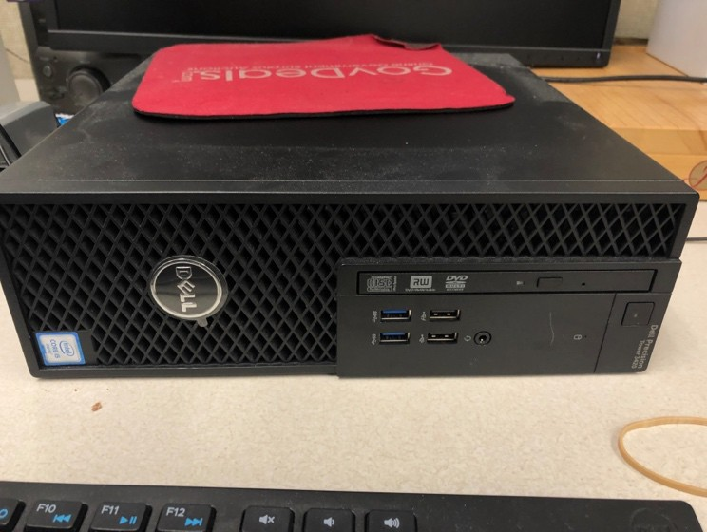

Among other items forensically collected, the Antrim County Election Management Server (EMS) with Democracy Suite was forensically collected. [Images 6 and 7].

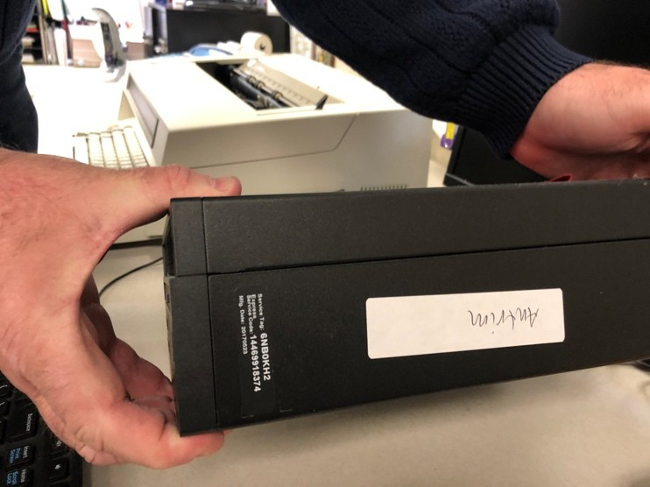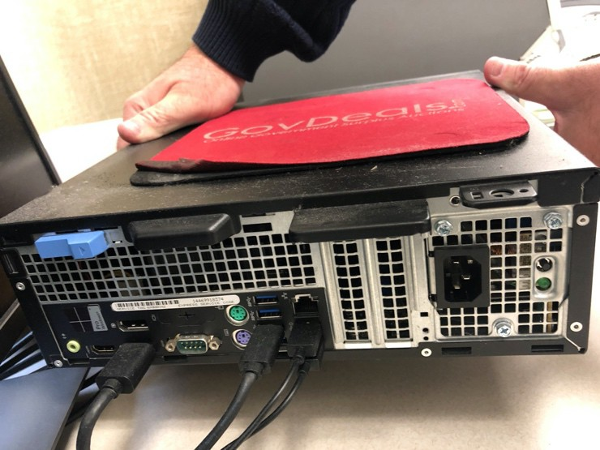

The EMS (Election Management Server) was a:

Dell Precision Tower 3420.

Service Tag: 6NB0KH2

The EMS contained 2 hard drives in a RAID-1 configuration. That is the 2 drives redundantly stored the same information and the server could continue to operate if either of the 2 hard drives failed. The EMS was booted via the Linux Boot USB memory sticks and both hard drives were forensically imaged.

At the onset of the collection process we observed that the initial program thumb drive was not secured in the vault with the CF cards and other thumbdrives. We watched as the County employees, including Clerk Sheryl Guy searched throughout the office for the missing thumb drive. Eventually they found the missing thumb drive in an unsecured and unlocked desk drawer along with multiple other random thumb drives. This demonstrated a significant and fatal error in security and election integrity.

FORENSIC COLLECTION

We used a built for purpose Linux Boot USB memory stick to boot the EMS in a forensically sound mode. We then used Ewfacquire to make a forensic image of the 2 independent internal hard drives.

Ewfacquire created an E01 file format forensic image with built-in integrity verification via MD5 hash.

We used Ewfverify to verify the forensic image acquired was a true and accurate copy of the original disk. That was done for both forensic images.

ANALYSIS TOOLS

X-Ways Forensics: We used X-Ways Forensics, a commercial Computer Forensic tool, to verify the image was useable and full disk encryption was not in use. In particular we confirmed that Bit locker was not in use on the EMS.

Other tools used: PassMark – OSForensics, Truxton - Forensics, Cellebrite – Physical Analyzer, Blackbag-Blacklight Forensic Software, Microsoft SQL Server Management Studio, Virtual Box, and miscellaneous other tools and scripts.

SERVER OVERVIEW AND SUMMARY

  - Our initial audit on the computer running the Democracy Suite Software showed that standard computer security best practices were not applied. These minimum-security standards are outlined the 2002 HAVA, and FEC Voting System Standards – it did not even meet the minimum standards required of a government desktop computer.

  - The election data software package USB drives (November 2020 election, and November 2020 election updated) are secured with bitlocker encryption software, but they were not stored securely on-site. At the time of our forensic examination, the election data package files were already moved to an unsecure desktop computer and were residing on an unencrypted hard drive. This demonstrated a significant and fatal error in security and election integrity. Key Findings on Desktop and Server Configuration: - There were multiple Microsoft security updates as well as Microsoft SQL Server updates which should have been deployed, however there is no evidence that these security patches were ever installed. As described below, many of the software packages were out of date and vulnerable to various methods of attack.

- Computer initial configuration on 10/03/2018 13:08:11:911

- Computer final configuration of server software on 4/10/2019

- Hard Drive not Encrypted at Rest

- Microsoft SQL Server Database not protected with password.

- Democracy Suite Admin Passwords are reused and share passwords.

- Antivirus is 4.5 years outdated

- Windows updates are 3.86 years out of date.

- When computer was last configured on 04/10/2019 the windows updates were 2.11 years out of date.

- User of computer uses a Super User Account.

  - The hard drive was not encrypted at rest – which means that if hard drives are removed or initially booted off an external USB drive the files are susceptible to manipulation directly. An attacker is able to mount the hard drive because it is unencrypted, allowing for the manipulation and replacement of any file on the system.

  - The Microsoft SQL Server database files were not properly secured to allow modifications of the database files.

  - The Democracy Suite Software user account logins and passwords are stored in the unsecured database tables and the multiple Election System Administrator accounts share the same password, which means that there are no audit trails for vote changes, deletions, blank ballot voting, or batch vote alterations or adjudication.

  - Antivirus definition is 1666 days old on 12/11/2020. Antrim County updates its system with USB drives. USB drives are the most common vectors for injecting malware into computer systems. The failure to properly update the antivirus definition drastically increases the harm cause by malware from other machines being transmitted to the voting system.

  - Windows Server Update Services (WSUS) Offline Update is used to enable updates the computer – which is a package of files normally downloaded from the internet but compiled into a program to put on a USB drive to manually update server systems.

  - Failure to properly update the voting system demonstrates a significant and fatal error in security and election integrity.

  - There are 15 additional updates that should have been installed on the server to adhere to Microsoft Standards to fix known vulnerabilities. For the 4/10/2019 install, the most updated version of the update files would have been 03/13/2019 which is 11.6.1 which is 15 updates newer than 10.9.1

This means the updates installed were 2 years, 1 month, 13 days behind the most current update at the time. This includes security updates and fixes. This demonstrated a significant and fatal error in security and election integrity.

    - Wed 04/10/2019 10:34:33.14 - Info: Starting WSUS Offline Update (v. 10.9.1)

    - Wed 04/10/2019 10:34:33.14 - Info: Used path "D:\WSUSOFFLINE1091_2012R2_W10\cmd\" on EMSSERVER (user: EMSADMIN)

    - Wed 04/10/2019 10:34:35.55 - Info: Medium build date: 03/10/2019

    - Found on c:\Windows\wsusofflineupdate.txt
    - *WSUS Offline Update (v.10.9.1) was created on 01/29/2017
*WSUS information found here https://download.wsusoffline.net/

  - Super User Administrator account is the primary account used to operate the Dominion Election Management System which is a major security risk. The user logged in has the ability to make major changes to the system and install software which means that there is no oversight to ensure appropriate management controls – i.e. anyone who has access to the shared administrator user names and passwords can make significant changes to the entire voting system. The shared usernames and passwords mean that these changes can be made in an anonymous fashion with no tracking or attribution.

ERROR RATES

  - We reviewed the Tabulation logs in their entirety for 11/6/2020. The election logs for Antrim County consist of 15,676 total lines or events.

    - Of the 15,676 there were a total of 10,667 critical errors/warnings or a 68.05% error rate.

    - Most of the errors were related to configuration errors that could result in overall tabulation errors or adjudication. These 11/6/2020 tabulation totals were used as the official results.

  - For examples, there were 1,222 ballots reversed out of 1,491 total ballots cast, thus resulting in an 81.96% rejection rate. Some of which were reversed due to "Ballot's size exceeds maximum expected ballot size".

    - According to the NCSL, Michigan requires testing by a federally accredited laboratory for voting systems. In section 4.1.1 of the Voluntary Voting Systems Guidelines (VVSG) Accuracy Requirements a. All systems shall achieve a report total error rate of no more than one in 125,000.

    - https://www.eac.gov/sites/default/files/eac_assets/1/28/VVSG.1.1.V OL.1.FINAL1.pdf

    - In section 4.1.3.2 Memory Stability of the VVSG it states that Memory devices used to retain election management data shall have demonstrated error free data retention for a period of 22 months.

    - In section 4.1.6.1 Paper-based System Processing Requirements sub- section a. of the VVSG it states "The ability of the system to produce and receive electronic signals from the scanning of the ballot, perform logical and numerical operations upon these data, and reproduce the contents of memory when required shall be sufficiently free of error to enable

satisfaction of the system-level accuracy requirement indicated in Subsection 4.1.1."

    - These are not human errors; this is definitively related to the software and software configurations resulting in error rates far beyond the thresholds listed in the guidelines.

  - A high "error rate" in the election software (in this case 68.05%) reflects an algorithm used that will weight one candidate greater than another (for instance, weight a specific candidate at a 2/3 to approximately 1/3 ratio). In the logs we identified that the RCV or Ranked Choice Voting Algorithm was enabled (see image below from the Dominion manual). This allows the user to apply a weighted numerical value to candidates and change the overall result. The declaration of winners can be done on a basis of points, not votes. [Image 8]:
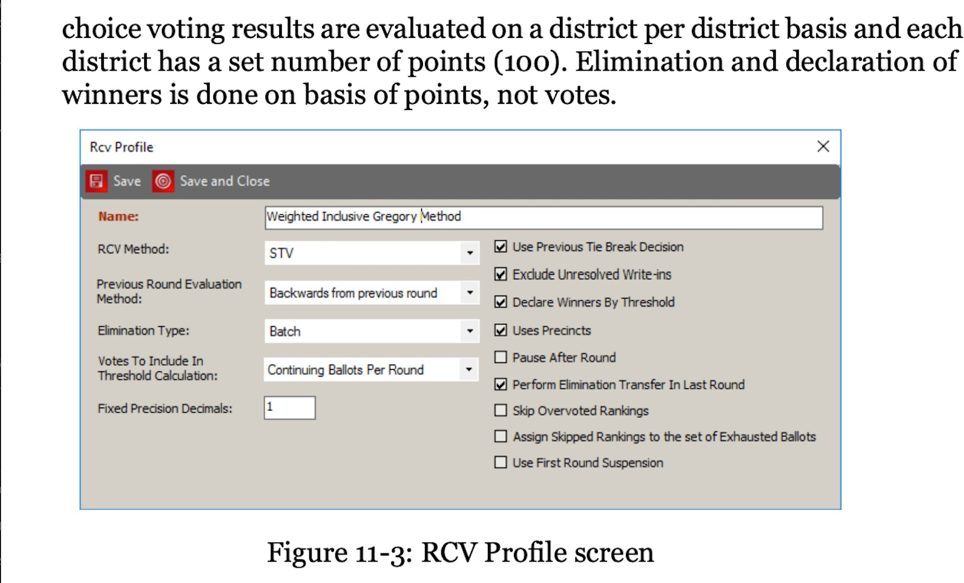
  - The Dominion software configuration logs in the Divert Options, shows that all write-in ballots were flagged to be diverted automatically for adjudication. This means that all write-in ballots were sent for "adjudication" by a poll worker or election official to process the ballot based on voter "intent". Adjudication files allow a computer operator to decide to whom to award those votes (or to trash them).

  - In the logs all but two of the Override Options were enabled on these machines, thus allowing any operator to change those votes. [Image 9]:

  - In the logs all but two of the Override Options were enabled on these machines, thus allowing any operator to change those votes. This gives the system operators carte blanche to adjudicate ballots, in this case 81.96% of the total cast ballots with no audit trail or oversight. [Image 10]:
  - On 12/8/2020 Microsoft issued 58 security patches across 10+ products, some of which were used for the election software machine, server and programs. Of the
58 security fixes 22, were patches to remote code execution (RCE) vulnerabilities. [Image 11]:

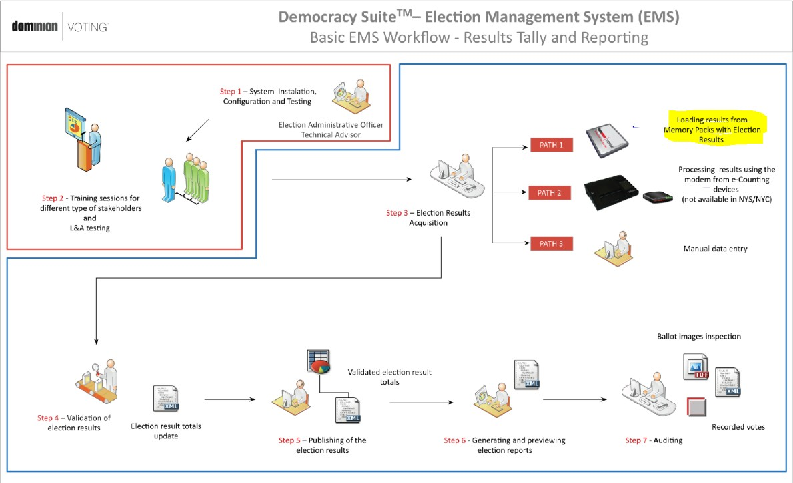

  - We reviewed the Election Management System logs (EmsLogger) in their entirety from 9/19/2020 through 11/21/2020 for the Project: Antrim November 2020. There were configuration errors throughout the set-up, election and tabulation of results. The last error for Central Lake Township, Precinct 1 occurred on 11/21/2020 at 14:35:11 System.Xml.XmlException System.Xml.XmlException: The ' ' character, hexadecimal value 0x20, cannot be included in a name. Bottom line is that this is a calibration that rejects the vote (see picture below). [Image 12]:

Notably 42 minutes earlier on Nov 21 2020 at 13:53:09 a user attempted to zero out election results. Id:3168 EmsLogger - There is no permission to {0}
- Project: User: Thread: 189. This is direct proof of an attempt to tamper with evidence.

  - The Election Event Designer Log shows that Dominion ImageCast Precinct Cards were programmed with updated new programming on 10/23/2020 and again after the election on 11/05/2020. As previously mentioned, this violates the HAVA safe harbor period.

Source: C:\Program Files\Dominion Voting Systems\Election Event Designer\Log\Info.txt
    - Dominion Imagecast Precinct Cards Programmed with 9/25/2020 programming on 09/29/2020, 09/30/2020, and 10/12/2020.

    - Dominion Imagecast Precinct Cards Programmed with New Ballot Programming dated 10/22/2020 on 10/23/2020 and after the election on 11/05/2020

Excerpt from 2020-11-05 showing “ProgramMemoryCard” commands.

  - Analysis is ongoing and updated findings will be submitted as soon as possible. A summary of the information collected is provided below.

10|12/07/20 18:52:30| Indexing completed at Mon Dec 7 18:52:30 2020 12|12/07/20 18:52:30| INDEX SUMMARY
12|12/07/20 18:52:30| Files indexed: 159312

12|12/07/20 18:52:30| Files skipped: 64799 12|12/07/20 18:52:30| Files filtered: 0 12|12/07/20 18:52:30| Emails indexed: 0
12|12/07/20 18:52:30| Unique words found: 5325413 12|12/07/20 18:52:30| Variant words found: 3597634 12|12/07/20 18:52:30| Total words found: 239446085 12|12/07/20 18:52:30| Avg. unique words per page: 33.43 12|12/07/20 18:52:30| Avg. words per page: 1503 12|12/07/20 18:52:30| Peak physical memory used: 2949 MB 12|12/07/20 18:52:30| Peak virtual memory used: 8784 MB 12|12/07/20 18:52:30| Errors: 10149
12|12/07/20 18:52:30| Total bytes scanned/downloaded: 1919289906

Dated: December 13, 2020 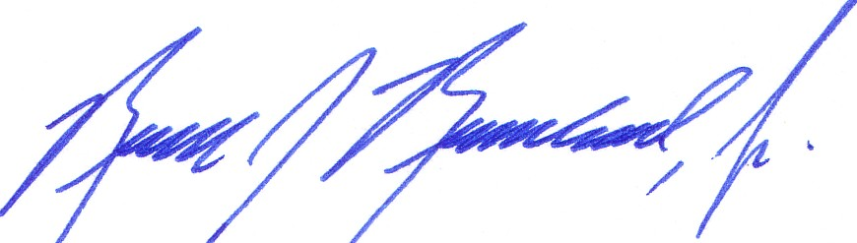

Russell Ramsland

